Main Agenda- to create a login screen for user login

1. Create a Ruleset

I am creatin as the “Test”

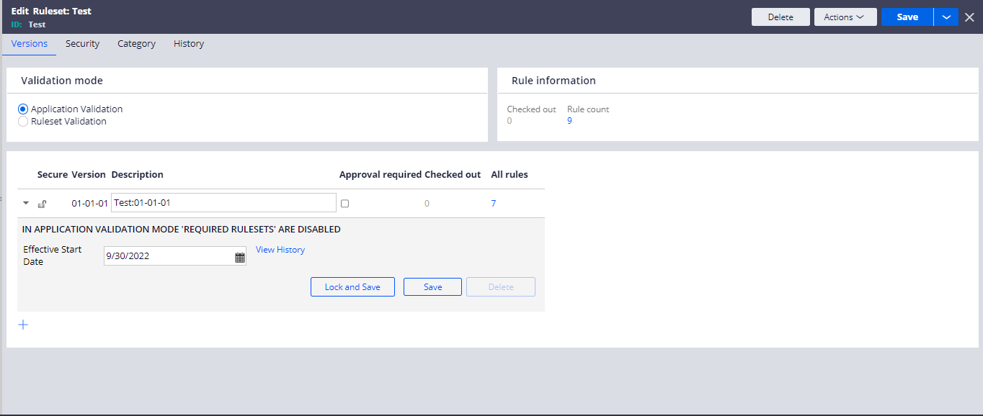

And in here we need to add the ruleset in the application list.

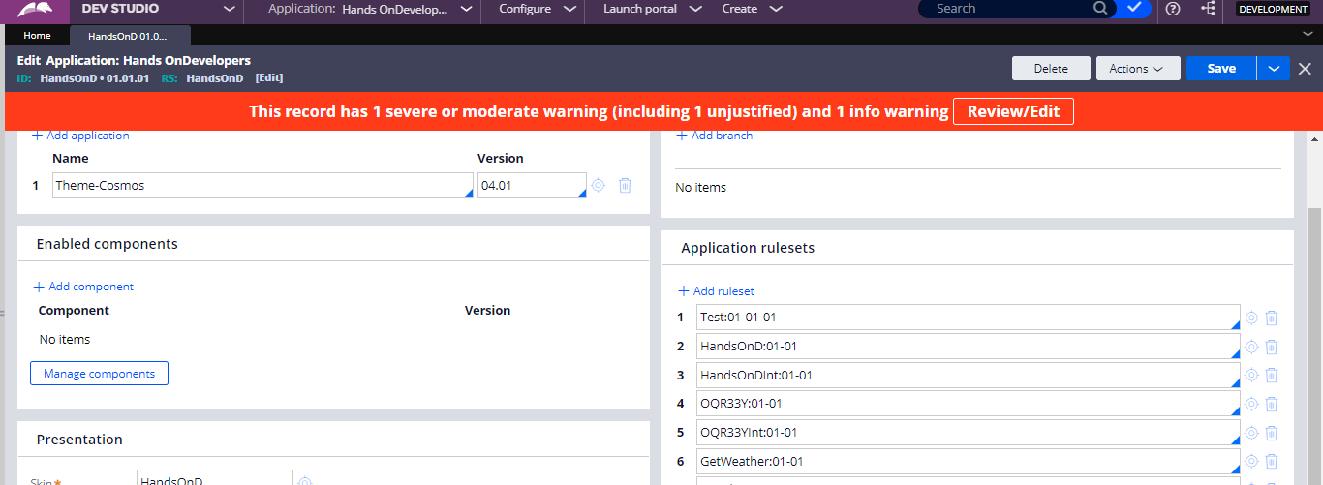

And after that we need to have to create the Access group and inside the access group we need to give the portals and we can give the application to access and then can give the version and portals and available roles as PegaRULES:Guest and in advanced tab give the work pol on which he can work and in the run time configuration can provide the created ruleset

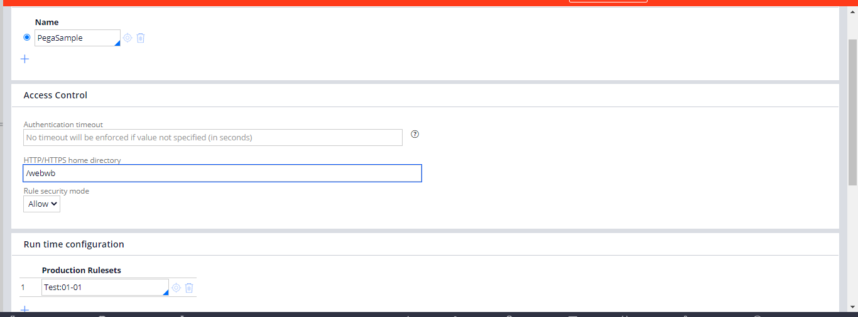

And after that we can go to the sysadmin> Requestor Type > Select Pega Browser and create access group and in the browser starting connection add your access group and add it

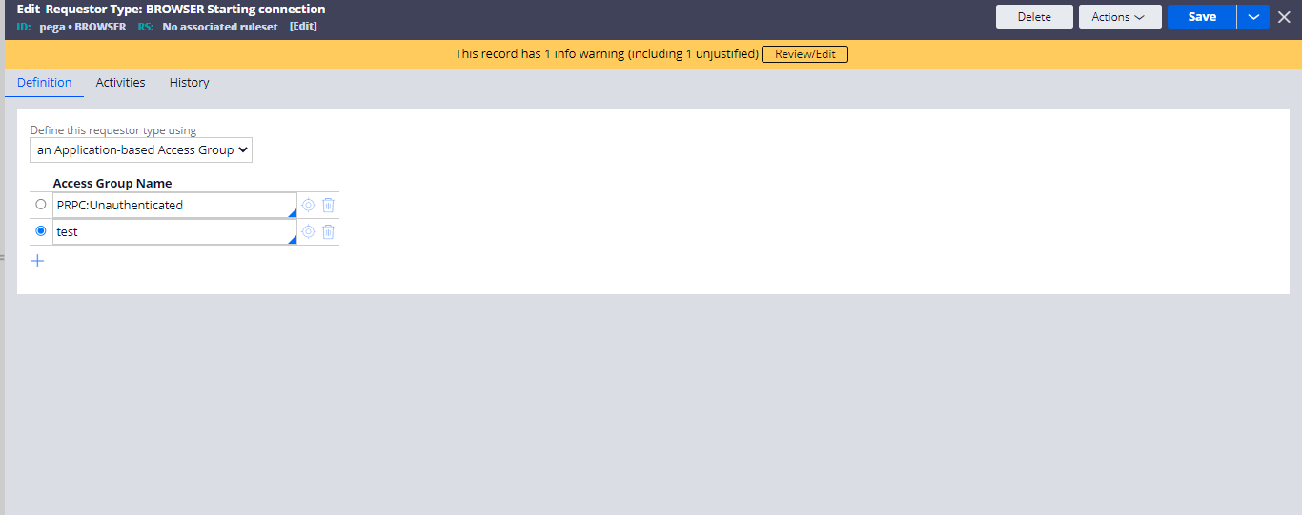

And then go for creating the custom activity for login page

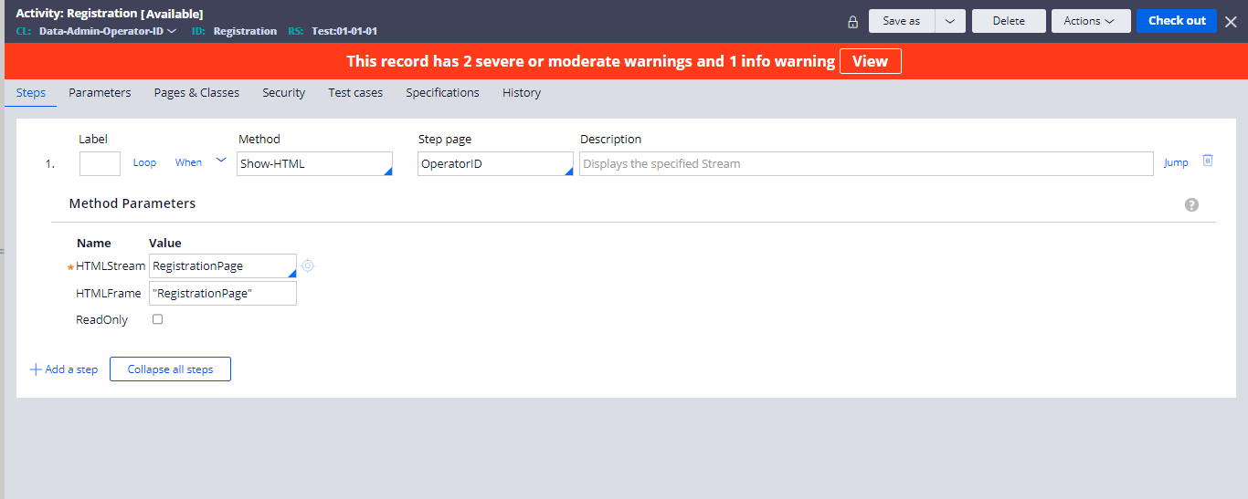

In this go for the HTML creation to login and then in the security tab tick the allow invocation from browser and add the privilege classes Data-Admin-Operator-ID and the Code-Pega-Requestor and then go for the and in the pages and classes add page name and class and then create the HTML

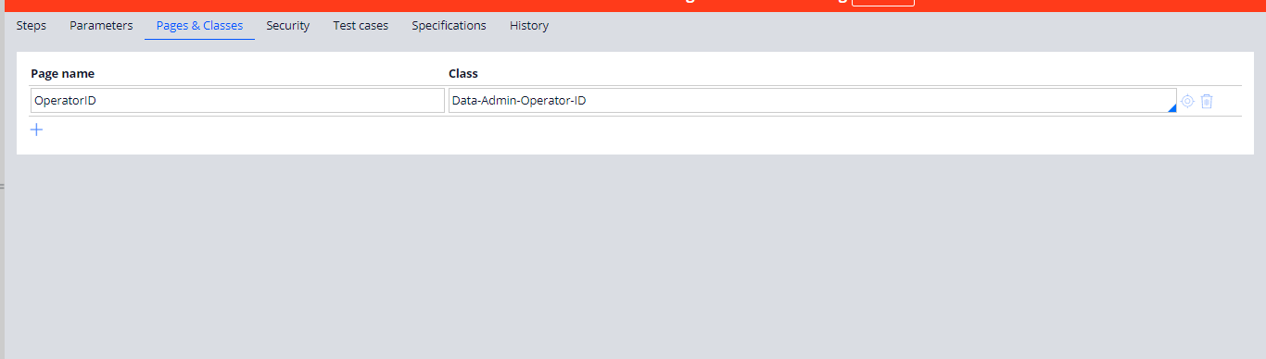

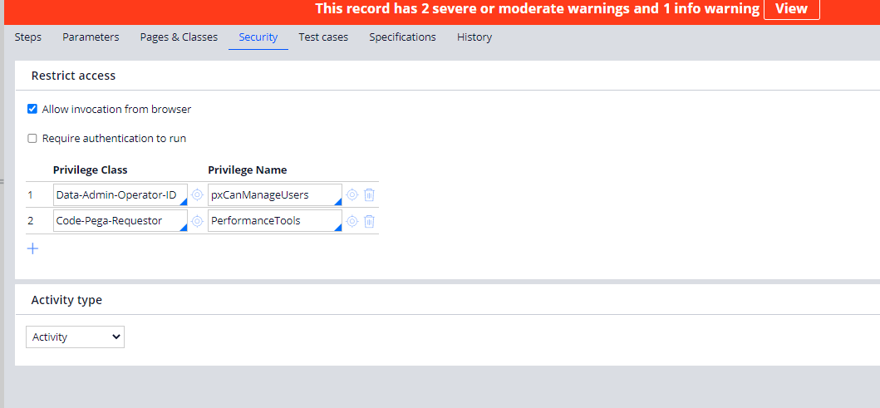

And then thew HTML

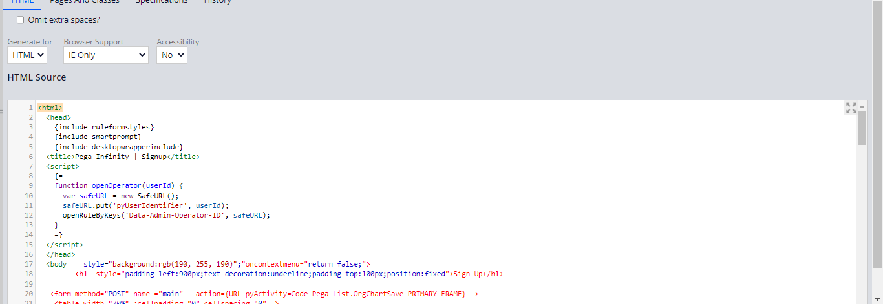

HTML Code

<html>

<head>

{include ruleformstyles}

{include smartprompt}

{include desktopwrapperinclude}

<title>Pega Infinity | Signup</title>

<script>

{=

function openOperator(userId) {

var safeURL = new SafeURL();

safeURL.put('pyUserIdentifier', userId);

openRuleByKeys('Data-Admin-Operator-ID', safeURL);

}

=}

</script>

</head>

<body style="background:rgb(190, 255, 190)";"oncontextmenu="return false;">

<h1 style="padding-left:900px;text-decoration:underline;padding-top:100px;position:fixed">Sign Up</h1>

<form method="POST" name ="main" action={URL pyActivity=Code-Pega-List.OrgChartSave PRIMARY FRAME} >

<table width="70%" ;cellpadding="0" cellspacing="0" >

<!-- header -->

<tr>

<td class="tableRightEdge"></td>

</tr>

<!-- input area -->

<tr>

<td nowrap="nowrap" style="border-left:1px solid darkgray>

<table cellpadding="0" cellspacing="0" width="100%" >

<tr>

<td style="padding:0px">

<!-- form elements: start -->

<div style="padding-top:200px; padding-left:780px">

<!-- title bar -->

<table width="100%" >

<TR>

<TD NOWRAP CLASS='dataLabelStyle' style="font-weight:700; ">First Name</TD>

<TD NOWRAP CLASS='dataStyle'> <INPUT NAME='param.firstName' value='{param.firstName}' size='30' maxlength='64' style="background:rgb(190, 255, 190);border-top:none;border-left:none;border-right:none;height:30px;margin:15px"> </TD> </TR>

<TR>

<TD NOWRAP CLASS='dataLabelStyle'style="font-weight: 700; ">Last Name</TD>

<TD NOWRAP CLASS='dataStyle'>

<INPUT NAME='param.lastName' value='{param.lastName}' size='30' maxlength='64' style="background:rgb(190, 255, 190);border-top:none;border-left:none;border-right:none;height:30px;margin:15px">

</TD>

</TR>

<TR>

<TD NOWRAP CLASS='dataLabelStyle'style="font-weight: 700; ">Title</TD>

<TD NOWRAP CLASS='dataStyle'>

<INPUT NAME='param.title' value='{param.title}' size='30' maxlength='64' style="background:rgb(190, 255, 190);border-top:none;border-left:none;border-right:none;height:30px;margin:15px">

</TD>

</TR>

<TR>

<TR>

<TD NOWRAP CLASS='dataLabelStyle'style=" font-weight: 700">Job Position</TD>

<TD NOWRAP CLASS='dataStyle'>

<INPUT NAME='param.position' value='{param.position}' size='30' maxlength='64' style="background:rgb(190, 255, 190);border-top:none;border-left:none;border-right:none;height:30px;margin:15px">

</TD>

</TR>

<TR>

<TD NOWRAP CLASS='dataLabelStyle'style="font-weight: 700;">Mobile Number</TD>

<TD NOWRAP CLASS='dataStyle'>

<INPUT NAME='param.telephone' value='{param.telephone}' size='30' maxlength='64' style="background:rgb(190, 255, 190);border-top:none;border-left:none;border-right:none;height:30px;margin:15px" >

</TD>

</TR>

<TR>

<TD NOWRAP CLASS='dataLabelStyle' style=" font-weight: 700;">Email ID</TD>

<TD NOWRAP CLASS='dataStyle'>

<INPUT NAME='param.userId' value='{param.userId}' size='30' maxlength='64' style="background:rgb(190, 255, 190);border-top:none;border-left:none;border-right:none;height:30px;margin:15px" >

</TD>

</TR>

<TR>

<TD NOWRAP CLASS='dataLabelStyle' style="font-weight: 700; ">Password</TD>

<TD NOWRAP CLASS='dataStyle'>

<INPUT type="password" NAME='param.password' value='{param.password}' size='30' maxlength='64' style="background:rgb(190, 255, 190);border-top:none;border-left:none;border-right:none;height:30px;margin:15px">

</TD>

</TR>

<TR>

</TR>

</table>

</div>

</td>

</tr>

</table>

</td>

<td class="tableRightEdge"></td>

</tr>

<!-- error area -->

<tr>

<td width="100%" nowrap="nowrap" style="border-left:1px solid darkgray" >

<table width="100%">

<tr><td>&nbsp;</td></tr>

<tr>

<td>

<label id="serverMessage">{param.message}</label>

<label style="color:red" id="serverError">{param.error}</label>

{when param.message != ""}

<span id="divOpenRecord">

<a title="Open the new operator record" href="#" onclick="javascript: openOperator('{param.tempUserId}'); return false;" class="action"> Open the new record</a>

</span>

{/when}

</td>

</tr>

</table>

</td>

<td class="tableRightEdge"></td>

</tr>

<tr>

<td nowrap="nowrap" align="center" style="padding-top:5px;padding-left:500px; padding-bottom:15px; border-left:1px solid darkgray">

<table cellpadding="0" cellspacing="0" width="100%">

<tr>

<td nowrap="nowrap" align="center" >

<button type="submit" name="pyActivity=Data-Admin-Operator-ID.CreateOperatorID" class="littleButton" style="background:purple;border-radius:10px " >

<span class="buttonLeft" style="background:purple"></span>

<span class="buttonMiddle">

<span class="buttonText" onmouseout="this.className='buttonText'" onmouseover="this.className='buttonTextHover'" style="background:purple" >Create</span>

</span>

<span class="buttonRight"style="background:purple"></span>

</button>

&nbsp;

<button onclick="window.close()" class="littleButton" style="background:purple;border-radius:10px">

<span class="buttonLeft" style="background:purple"></span>

<span class="buttonMiddle">

<span class="buttonText" onmouseout="this.className='buttonText'" onmouseover="this.className='buttonTextHover'" style="background:purple">Cancel</span>

</span>

<span class="buttonRight" style="background:purple"></span>

</button>

</td>

</tr>

</table>

</td>

<td class="tableRightEdge"></td>

</tr>

<tr>

<td nowrap="nowrap" class="tableBottomEdge"></td>

<td nowrap="nowrap" class="tableBottomRightCorner"></td>

</tr>

</table>

</form>

</body>

</html>

And then again customize another activity which is given by pega which is “CreateOperator open and save as into the created ruleset

And then add the required parameters and steps in the activity

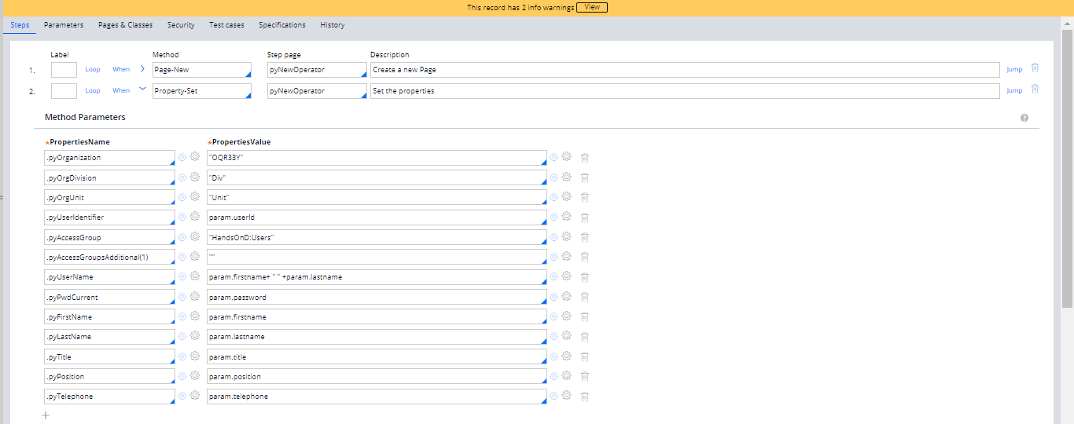

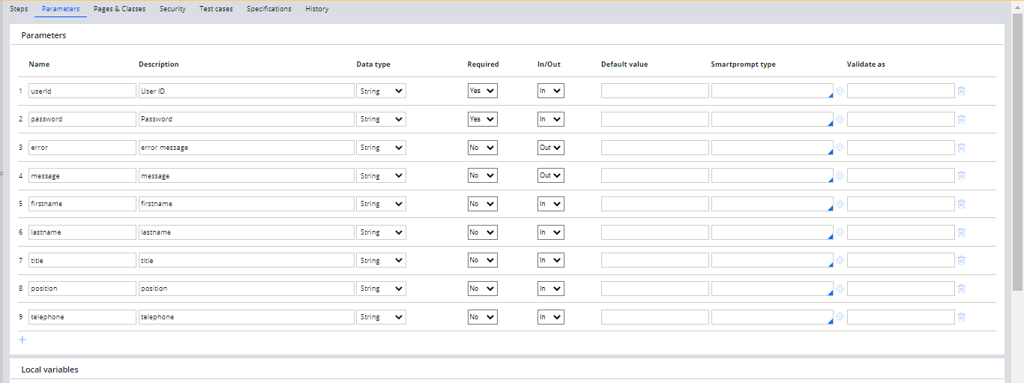

And in the final steps add the Call and create an activity and success message and in the activity go for another HTML and go for the SuccessMessage

<html>

<head>

{include RuleformStyles}

{include SmartPrompt}

{include DesktopWrapperInclude}

<title>New Operator</title>

<script>

{=

function openOpe<rator(userId) {

var safeURL = new SafeURL();

safeURL.put('pyUserIdentifier', userId);

openRuleByKeys('Data-Admin-Operator-ID', safeURL);

}

=}

</script>

</head>

<body oncontextmenu="return false;" style="background:rgb(190, 255, 190)">

<h1 style="text-decoration: underline ;position:fixed;padding-left:850px;padding-top:200px">Congratulations</h1>

<img src="webwb/Tick.gif" style="position:fixed;padding-left:880px;padding-top:250px;width:120px;height:120px">

<h2 style="position:fixed;padding-left:750px;padding-top:350px ">your account has been created successfully<h2>

<h2 style="position:fixed;padding-left:795px;padding-top:372px">Login with your Email id & Password<h2>

<button><a href="http://localhost:9080/prweb/DGUM90lACED74DAWt5QdLQ%5B%5B\*/!STANDARD" style="position:fixed;padding-left:895px;padding-top:425px;color:black;font-size:20px;">Login Now</a>

</body>

</html>

And then add the HTML and save the activity an din the parameters and then in the security and allow invocation and give the privilege classes and save the Activity

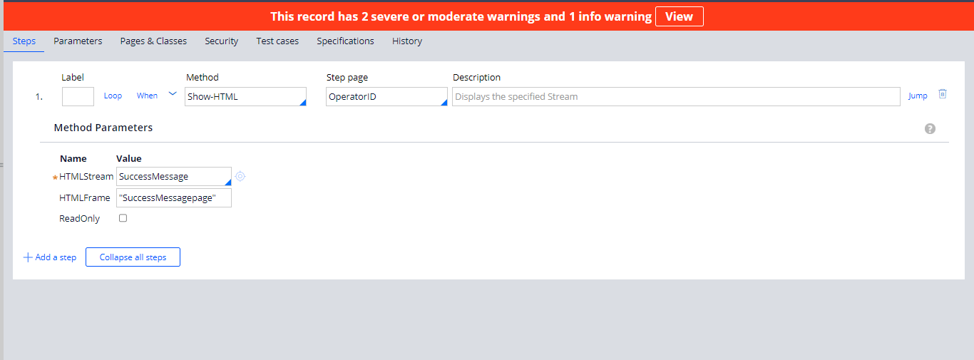

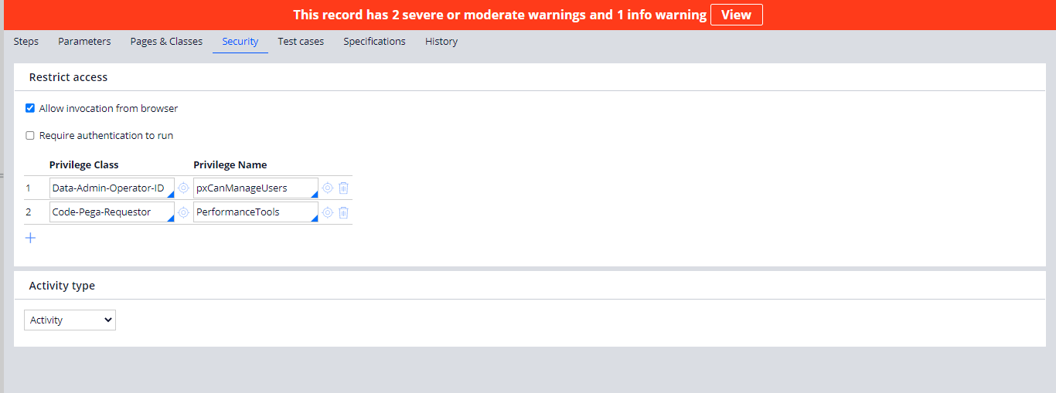

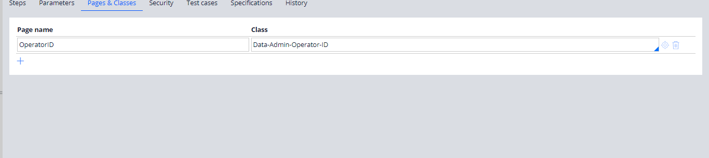

and then we can go for the Web-Login and add the URL of our browser and go for the usage of the login

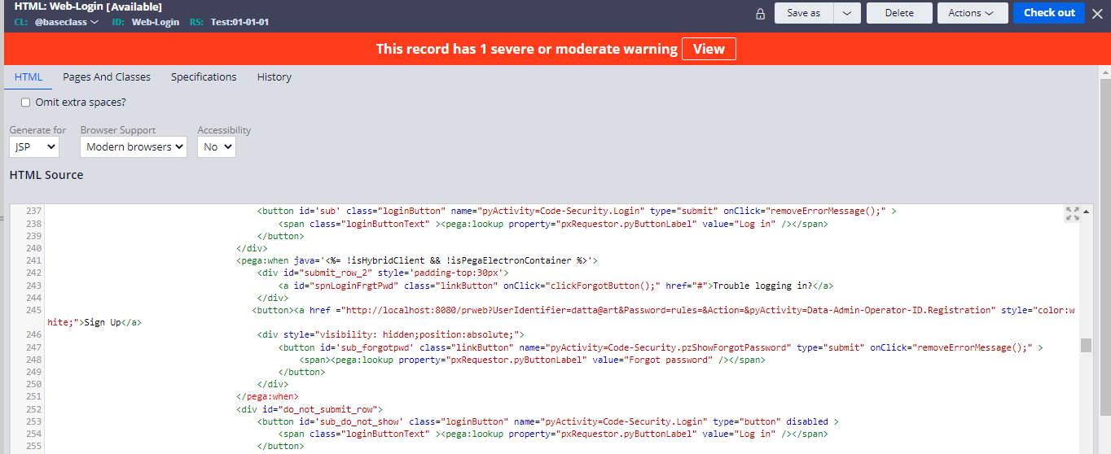

And then go for the login and then create binary file for success message

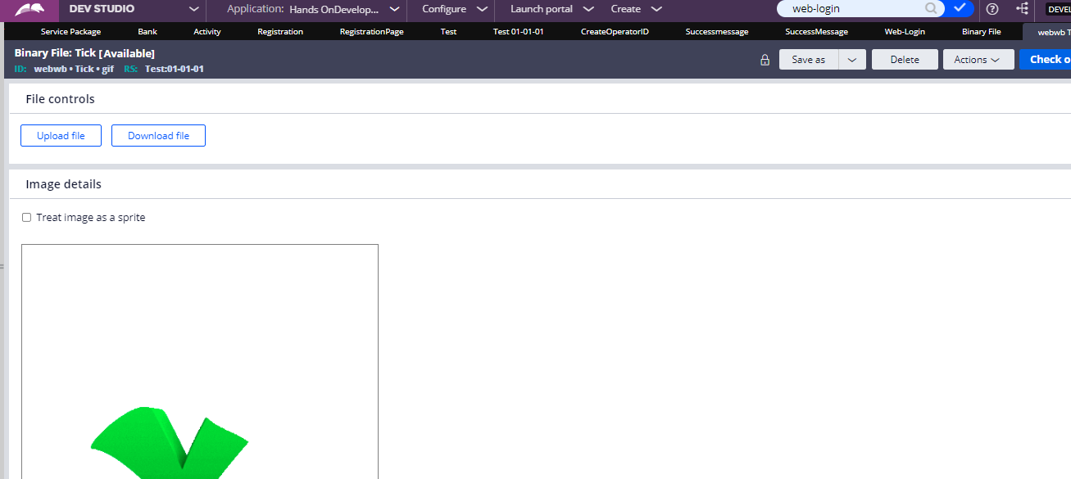

And then go for the login with the URL

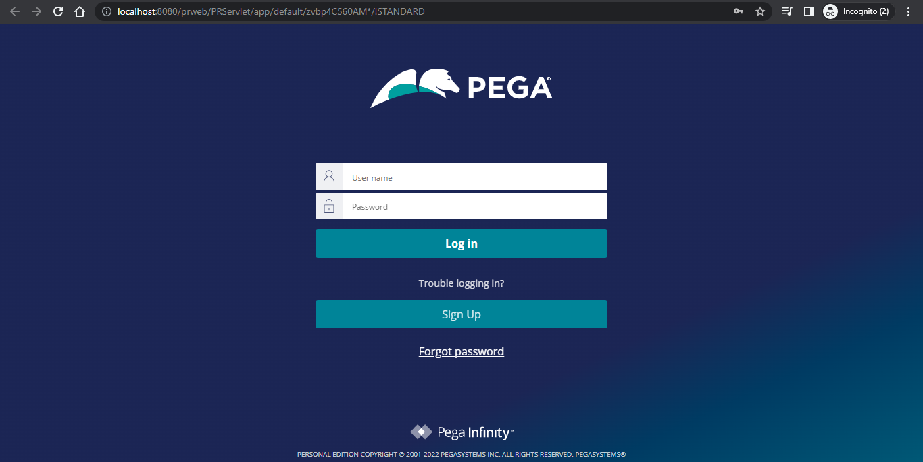

And then



And then go for the



And then login

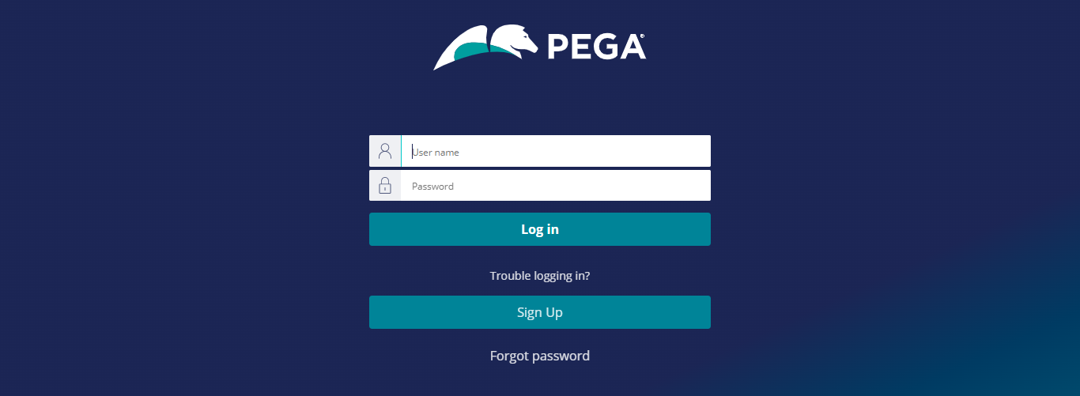

And then login to the casemanager7 portal

